- FCFS Scheduling algorithm
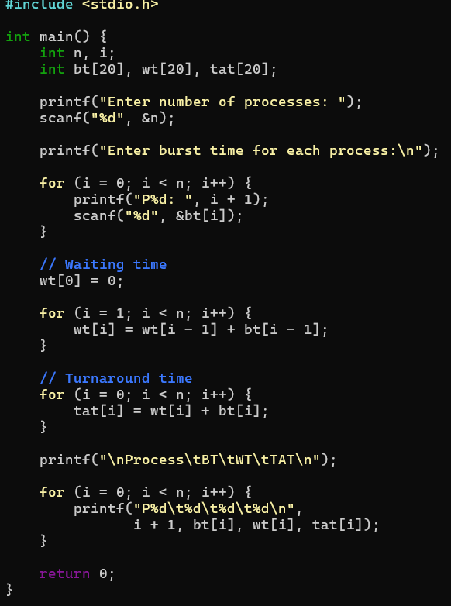
OUTPUT:
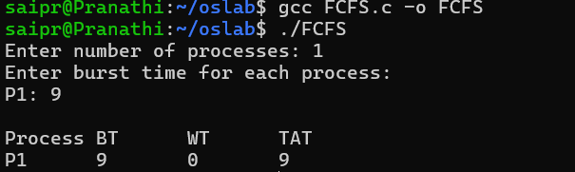

- SJF_NONpreemptive
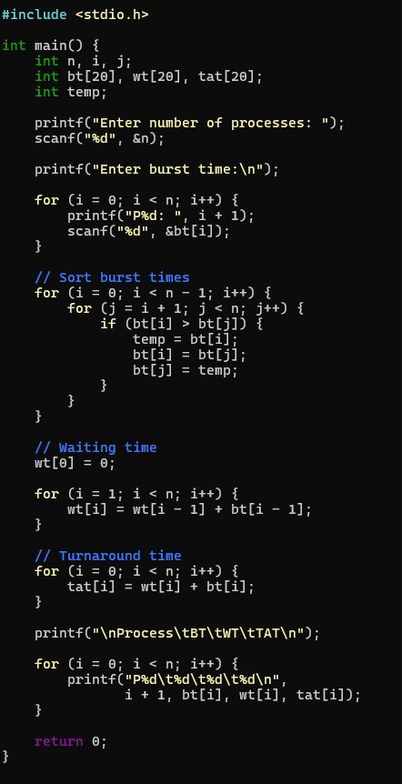
OUTPUTS:
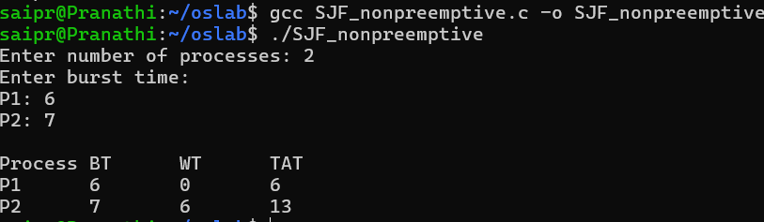

- Priority

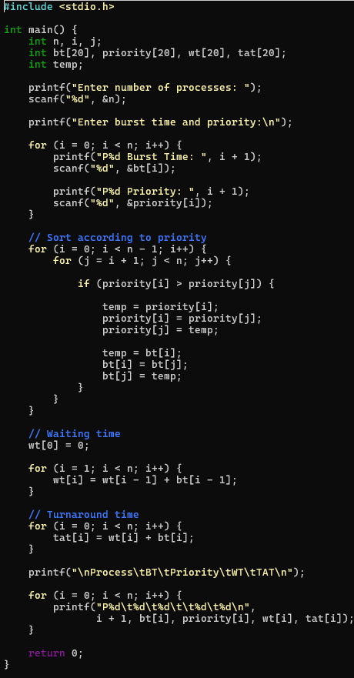
OUTPUT:
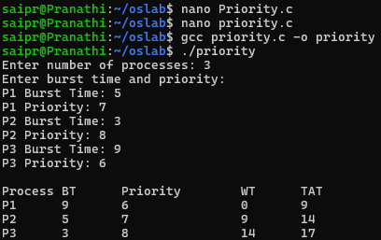

- ROUND ROBIN
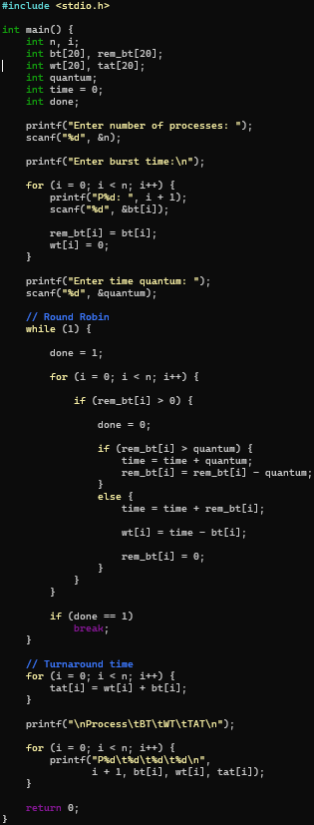
OUTPUT:
